**CABLES & WIRES**

**1. Armoured Cables**

* Cables and wires are two different things. Cables are the bundle of metal wire wrapped inside a single sheathing whereas wire is a single electrical conductor. However, both the cable and wires plays the same role to carry and circulate the electric current.
* Electric cables and wire are both conductors that pass on electric current from any power source, it can be from a nearby transformer or anything and then transfers it to your household, office, factory, etc.
* For different-different purposes, we have different-different cables and wires for you. We have wide varieties of wires and cables from which you can choose from like- House Wires, Flexible Wire, Multi-core Cable and Wire, Camera Wires, Armoured Cables, Solar Dc Wires, Shield Wires, Fibreglass Cables, etc.
* List of products:

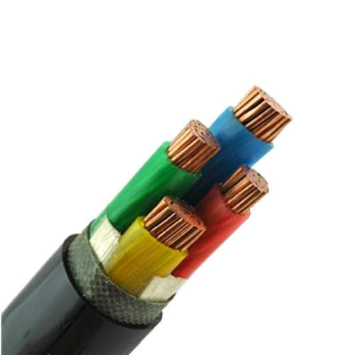**No1:** KEI 1.5 sqmm 2 core Copper Armoured Control Cable

Selling Price: Rs. 96

You Save: Rs. 29.00 (23.20%)

(Price Inclusive of GST)

Electrical armoured electric cable has higher compressive strength and tensile property. That's to say STA armoured cable can bear certain mechanical forces and SWA armoured cable can bear some pulling forces so these kinds of armoured cables are  widely used in tunnel, railway, underground, and large drop height etc

**PRODUCT SPECIFICATION**

|  |  |
| --- | --- |
| **Brand** | KEI |
| **Product Category** | Copper Control Cables |
| **Size of Conductor** | 1.5 sq mm |
| **Core** | 2 Core |
| **Conductor Material** | Copper |
| **Colour** | Black |
| **Overall Diameter (Strip/Wire)** | 13.2 mm |
| **Current Rating (A)** | 33 Amp |
| **Thickness of PVC Insulation** | 0.7 mm |
| **Min.thickness of pvc inner sheath** | 0.3 mm |

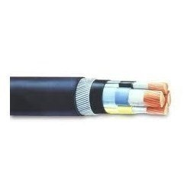**No2:** Havells 1.5 sqmm 2 core Copper Armoured Control Cable

Selling Price: Rs. 96

You Save: Rs. 29.00 (23.20%)

(Price Inclusive of GST)

These high voltage cables are designed for installation mostly in power supply stations, indoors and in cable ducts, outdoors, underground and in water as well as for installation on cable trays for industries, switchboards and power stations.

**PRODUCT SPECIFICATION**

|  |  |
| --- | --- |
| **Brand** | Havells |
| **Product Category** | Copper Control Cables |
| **Size of Conductor** | 1.5 sq mm |
| **Core** | 2 Core |
| **Conductor Material** | Copper |
| **Colour** | Black |
| **Overall Diameter (Strip/Wire)** | 13.2 mm |
| **Current Rating (A)** | 33 Amp |
| **Thickness of PVC Insulation** | 0.7 mm |
| **Min.thickness of pvc inner sheath** | 0.3 mm |

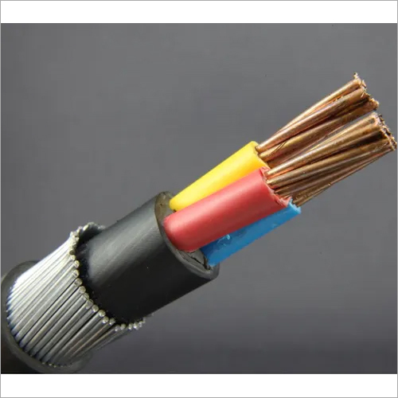**No3:** Polycab 1.5 sqmm 2 core Copper Armoured Control Cable

Selling Price: Rs. 96

You Save: Rs. 29.00 (23.20%)

(Price Inclusive of GST)

Flexible insulated conductor cable used for laying in electric-installation tubes, under and on plaster installation in dry rooms and in closed installation conduits. Direct laying in cable guides is not permitted. Also applied forinternal wiring of distribution and switching boxes equipment, same as for protective laying for lighting of nominal voltage up to 1000 V alternating current, or up to 750 V direct current against earth.

**PRODUCT SPECIFICATION**

|  |  |
| --- | --- |
| **Brand** | Polycab |
| **Product Category** | Copper Control Cables |
| **Size of Conductor** | 1.5 sq mm |
| **Core** | 2 Core |
| **Conductor Material** | Copper |
| **Colour** | Black |
| **Overall Diameter (Strip/Wire)** | 13.2 mm |
| **Current Rating (A)** | 33 Amp |
| **Thickness of PVC Insulation** | 0.7 mm |
| **Min.thickness of pvc inner sheath** | 0.3 mm |

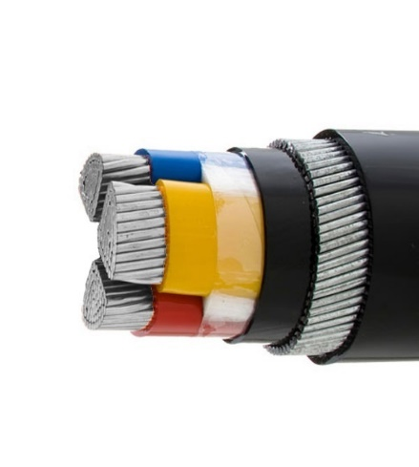**No4:** Havells 6 sqmm 3 core Aluminium Armoured Power Cable

Selling Price: Rs. 109

You Save: Rs. 32.00 (22.70%)

(Price Inclusive of GST)

Flame retardant PVC insulated PVC sheathed power cable (FR/PVC/PVC Cable), For exposed and concealed wiring in dry or wet locations and where exposed to the weather.For use in ventilated, non-ventilated and ladder type cable trays in wet and dry locations

**PRODUCT SPECIFICATION**

|  |  |
| --- | --- |
| **Brand** | Havells |
| **Product Category** | Aluminium Power Cable |
| **Size of Conductor** | 6 sq mm |
| **Core** | 3 Core |
| **Conductor Material** | Aluminium |
| **Colour** | Black |
| **Overall Diameter (Strip/Wire)** | 17.4 mm |
| **Current Rating (A)** | 43 Amp |
| **Thickness of PVC Insulation** | 0.7 mm |
| **Min.thickness of pvc inner sheath** | 0.3 mm |
| **Nominal Dimensions of Armoui (Strip / Wire)** | 1.4 mm |
| **Min. Thickness Of PVC Outer Sheath (Strip / Wire)** | 1.24 mm |
| **Max DC Resistance ohm** | 4.16 Ohm |
| **Max. AC Resistance ohm** | 5.9 Ohm |
| **Approx. Reactance at 50Hz Ohms/Km** | 0.0884 |
| **Capacitance mFd/Krr** | 0.25 |

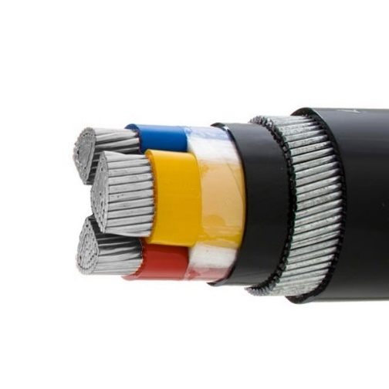**No5:** Polycab 6 sq mm 3 core Aluminium Armoured Power Cable

Selling Price: Rs. 109

You Save: Rs. 32.00 (22.70%)

(Price Inclusive of GST)

Medium Voltage Fill Shield Power Cables are intended for use in dry or wet locations for distribution of three-phase medium-voltage power. Because it's filled with shield, these medium voltage cables may be installed in ducts or direct buried.

**PRODUCT SPECIFICATION**

|  |  |
| --- | --- |
| **Brand** | Polycab |
| **Product Category** | Aluminium Power Cable |
| **Size of Conductor** | 6 sq mm |
| **Core** | 3 Core |
| **Conductor Material** | Aluminium |
| **Colour** | Black |
| **Overall Diameter (Strip/Wire)** | 17.4 mm |
| **Current Rating (A)** | 43 Amp |
| **Thickness of PVC Insulation** | 0.7 mm |
| **Min.thickness of pvc inner sheath** | 0.3 mm |
| **Nominal Dimensions of Armoui (Strip / Wire)** | 1.4 mm |
| **Min. Thickness Of PVC Outer Sheath (Strip / Wire)** | 1.24 mm |
| **Max DC Resistance ohm** | 4.16 Ohm |
| **Max. AC Resistance ohm** | 5.9 Ohm |
| **Approx. Reactance at 50Hz Ohms/Km** | 0.0884 |
| **Capacitance mFd/Krr** | 0.25 |

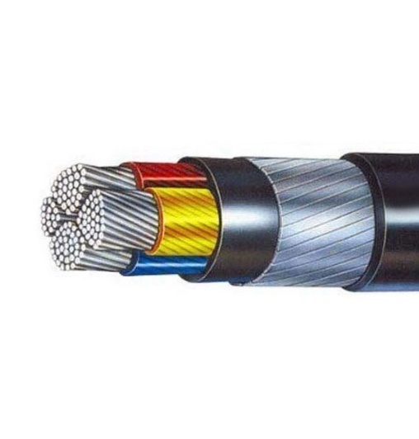**NO6:** KEI 70 sqmm 3.5 core Aluminium Armoured Power Cable

Selling Price: Rs. 470

You Save: Rs. 141.00 (23.08%)

(Price Inclusive of GST)

**PRODUCT SPECIFICATION**

|  |  |
| --- | --- |
| **Brand** | KEI |
| **Product Category** | Aluminium Power Cable |
| **Size of Conductor** | 70 sq mm |
| **Core** | 3.5 Core |
| **Type** | A2xwy |
| **Conductor Material** | Aluminium |
| **Colour** | Black |
| **Overall Diameter (Strip/Wire)** | 34 mm / 31.6 mm |
| **Current Rating (A)** | 176 Amp |
| **Thickness of PVC Insulation** | 1.1 / 0.9 mm |
| **Min.thickness of pvc inner sheath** | 0.4 mm |
| **Nominal Dimensions of Armoui (Strip / Wire)** | 4 x 0.8 mm |
| **Min. Thickness Of PVC Outer Sheath (Strip / Wire)** | 1.56 mm |
| **Max DC Resistance ohm** | 0.443 Ohm |
| **Max. AC Resistance ohm** | 0.567 Ohm |
| **Approx. Reactance at 50Hz Ohms/Km** | 0.077 |
| **Capacitance mFd/Krr** | 0.26 |

**2. House Wires**

* Wires are basic element for electricity transmission in buildings. Three best quality electrical wires for house are - FR, FRLS and ZHFR or LSZH.
* FR (Fire Retardant) wires are manufactured with a fire retardant compound to offer extra safety and are widely used in homes. In offices, FRLS (Flame Retardant Low Smoke) wires are preferred and are safer alternative than FR. They cost typically 5-10% higher than FR wires. During short circuits/fire, FRLS compound restricts spread of blaze and smoke emission is less in comparison to the ordinary FR wires. Hence FRLS wires are recommended for commercial infrastructure as well as all public spaces. Next ZHFR (Zero Halogen Flame Retardant) or LSZH (Low Smoke Zero Halogen) wires have minimal smoke and are non-toxic. Recommended for Underground public spaces like Metro Rail, etc.
* List of products:

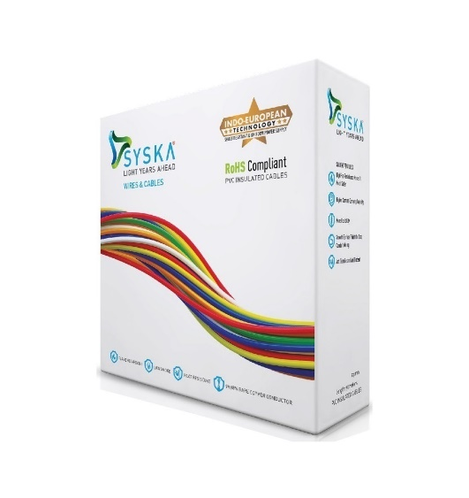**No1:** Syska 1 sq mm 90 mtr FR House Wire

Selling Price: Rs. 1165

You Save: Rs. 348.00 (23.00%)

(Price Inclusive of GST)

Ensure the safety of your house with 1mm 90 mtr fire resistant & flame retardant (FR) insulated copper house wire from Syska. These good value wires don’t get overheated and hence are long lasting and durable.

Grab this high quality wire today that can be used at various places in your house. This Syska 1mm 90mtr fire resistant & flame retardant (FR) insulated copper house wire is insulated by best quality PVC, which makes the wire easy to work with and has the better insulation as compared to conventional wires.

**PRODUCT SPECIFICATION**

|  |  |
| --- | --- |
| **Brand** | Syska |
| **Product Category** | FR House Wire |
| **Size of Conductor** | 1 sq mm |
| **Max. Overall Diameter** | 3.0 mm |
| **Conductor Material** | Copper |
| **Resistance (Max.) per Km at 20° C** | 19.50 ohm |
| **Current Rating (Casing)** | 12 Amps |
| **Current Rating (Concealed)** | 11 Amps |
| **Insulation Material** | FR PVC |
| **Thickness of Insulation (Nom.)** | 0.6 mm |
| **Packing** | Retail Pack |
| **Length** | 90 mtr |
| **Colour** | Black, Blue, Red, Green & Yellow |
| **Certification** | CE |

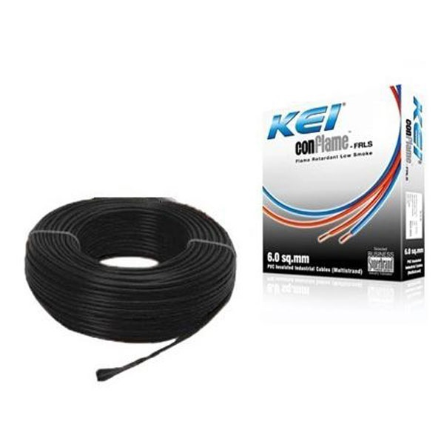**No2:** KEI 1 sq mm 90 mtr FRLS House Wire

Selling Price: Rs. 1189

You Save: Rs. 586.00 (33.01%)

(Price Inclusive of GST)

This is a special quality wire that ensures the safe working of electrical devices at home. This 1mm 90mtr fire resistant & flame retardant low smoke (FRLS) insulated copper house wire from KEI is made from high quality PVC that protects both appliances and users from electrical leakages.  
This is a standard product of electrical wires from KEI i.e. ideal for wiring of electrical control panels, industrial sheds, buildings etc., where increased fire safety is desired. This KEI 1mm 90mtr FRLS House Wire is shielded by a specially formulated flame retardant low smoke PVC compound that retards spread of fire and emits minimum smoke and toxic gases, thereby reducing the risk of injury.

**PRODUCT SPECIFICATION**

|  |  |
| --- | --- |
| **Brand** | KEI |
| **Product Category** | FRLS House Wire |
| **Size of Conductor** | 1 sq mm |
| **Max. Overall Diameter** | 3.0 mm |
| **Conductor Material** | Copper |
| **Resistance (Max.) per Km at 20° C** | 19.50 ohm |
| **Current Rating (Casing)** | 12 Amps |
| **Current Rating (Concealed)** | 11 Amps |
| **Insulation Material** | FRLS PVC |
| **Thickness of Insulation (Nom.)** | 0.6 mm |
| **Packing** | Retail Pack |
| **Length** | 90 mtr |
| **Colour** | Black, Blue, Red, Green, Yellow, White & Grey |
| **Certification** | CE |

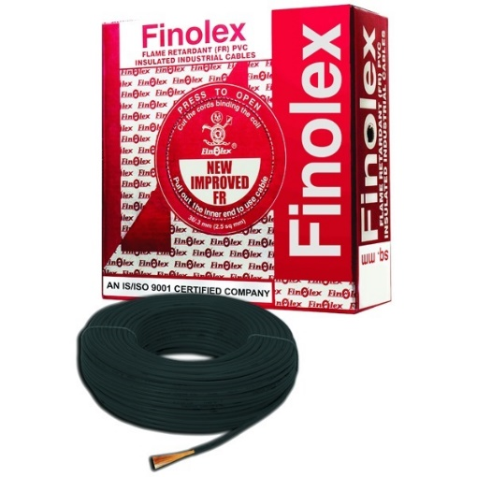**No3:** Finolex 1 sq mm 90 mtr FR House Wire

Selling Price: Rs. 1220

You Save: Rs. 305.00 (20.00%)

(Price Inclusive of GST)

Manufactured from bright annealed 99.97% pure bare copper conductors these cables have low conductor resistance resulting in power saving. These wires are insulated with a special grade PVC compound formulated and manufactured in-house. The insulation is far superior in terms of critical oxygen and temperature index and also in light transmission and acid gas generation. These wires conform to IS 694:1990 and also have FIA/TAC (Fire Insurance/Tariff Advisory Committee) approval.

**PRODUCT SPECIFICATION**

|  |  |
| --- | --- |
| **Brand** | Finolex |
| **Product Category** | FR House Wire |
| **Size of Conductor** | 1 sq mm |
| **Max. Overall Diameter** | 2.7 mm |
| **Conductor Material** | Copper |
| **Resistance (Max.) per Km at 20° C** | 18.10 ohm |
| **Current Rating (Casing)** | 11 Amps |
| **Current Rating (Concealed)** | 12 Amps |
| **Insulation Material** | FR PVC |
| **Thickness of Insulation (Nom.)** | 0.7 mm |
| **Packing** | Retail Pack |
| **Length** | 90 mtr |
| **Colour** | Black, Blue, Red, Green & Yellow |
| **Certification** | BIS |

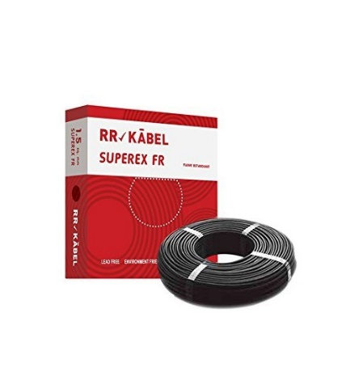**No4:** RR Kabel 1 sq mm 90 mtr Superex FR House Wire

Selling Price: Rs. 1265

You Save: Rs. 357.00 (22.01%)

(Price Inclusive of GST)

Ensure the safety of your house with 1mm 90mtr fire resistant & flame retardant (FR) insulated copper house wire from RR Kabel. These good value wires don’t get overheated and hence are long lasting and durable.  
Grab this 1mm 90mtr fire resistant & flame retardant (FR) insulated copper house wire high quality wire today that can be used at various places in your house. This wire is insulated by best quality PVC, which makes the wire easy to work with and has the better insulation as compared to conventional wires.

**PRODUCT SPECIFICATION**

|  |  |
| --- | --- |
| **Brand** | RR Kabel |
| **Product Category** | FR House Wire |
| **Size of Conductor** | 1 sq mm |
| **Max. Overall Diameter** | 2.7 mm |
| **Conductor Material** | Copper |
| **Resistance (Max.) per Km at 20° C** | 18.10 ohm |
| **Current Rating (Casing)** | 14 Amps |
| **Current Rating (Concealed)** | 13 Amps |
| **Insulation Material** | FR PVC |
| **Thickness of Insulation (Nom.)** | 0.7 mm |
| **Packing** | Retail Pack |
| **Length** | 90 mtr |
| **Colour** | Black, Blue, Red, Green & Yellow |
| **Certification** | BIS |

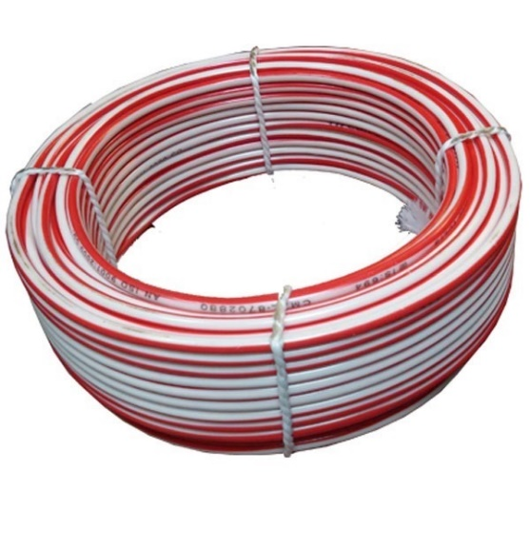

**No5:** Tipcon 4 sq mm 30 mtr FR House Wire

Selling Price: Rs. 1284

You Save: Rs. 428.00 (25.00%)

(Price Inclusive of GST)

Ensure the safety of your house with 4mm 30 Mtr fire resistant & flame retardant (FR) insulated copper house wire from Tipcon. These good value wires don’t get overheated and hence are long lasting and durable.

Grab this high quality wire today that can be used at various places in your house. This Tipcon 4mm 30 Mtr fire resistant & flame retardant (FR) insulated copper house wire is insulated by best quality PVC, which makes the wire easy to work with and has the better insulation as compared to conventional wires.

**PRODUCT SPECIFICATION**

|  |  |
| --- | --- |
| **Brand** | Tipcon |
| **Product Category** | FR House Wire |
| **Size of Conductor** | 4 sq mm |
| **Max. Overall Diameter** | 4.3 mm |
| **Conductor Material** | Copper |
| **Resistance (Max.) per Km at 20° C** | 4.91 ohm |
| **Current Rating (Casing)** | 24 Amps |
| **Current Rating (Concealed)** | 29 Amps |
| **Insulation Material** | FR PVC |
| **Thickness of Insulation (Nom.)** | 0.8 mm |
| **Packing** | Nano Pack |
| **Length** | 30 mtr |
| **Colour** | Red & Black |
| **Certification** | ISI |